Final Report Project 3
CIVE-202 04/21/2026
Group members: Fatima Davila, Harrison Drake, Michael McCarthy

Table of Contents
Introduction 2
Methods 3
Results 3
References 4
Figure 1displays the South Dakota map with the risk score we created 3
Figure 3 shows the tornado risk in South Dakota as defined by NRI 4

Introduction
In this project Risk Averse, LLC has charged our team to perform a sensitivity analysis to evaluate the potential of bias within FEMA’s National Risk Index (NRI) scoring methods. In the NRI, FEMA defines risk as the product of the probability of a natural disaster and the expected outcome and damage of the natural disaster scenario. This rating system for risk is percentile score for individual communities ranks them from “Very Low” to “Very High” based on their percentile ranking compared to other communities at the same level of risk. Withing these ratings, the communities also receive ratings based on Expected Annual Loss, Social Vulnerability, and Community Resilience.
The overall goal of our group was to perform a sensitivity analysis on where bias may exist in the NRI scoring methods. This will be accomplished by varying the input to the risk rating methodology of the NRI by evaluating and comparing the inputs and outputs of two different U.S. states. The current risk levels of these selected states with the NRI will then also be compared to independent consultants’ definition of risk methodology to compare the results.
Risk Averse has also tasked us with researching and then developing an alternative risk scoring method so that it can be used to determine if there is bias by using the NRI dataset as an input. This developed risk assessment system will then be used to evaluate the risk assessment of the two selected states for comparison with the current NRI risk scores of these states.

Methods
FEMA’s National Risk index defines their risk score as a representation of a community's total value in comparison to all other communities at their same level. Their risk index is a representation of the average loss in dollars for each of the consequence types each year to a community due to natural hazards based on the community’s social Vulnerability and community resilience (Federal Emergency Management Agency. (2026, April 8)). For this project our client asked us to define our own risk that is different from the one FEMA uses for their analysis. We changed our definition of risk to be more specific to the states in which we are studying; South Dakota and Iowa which are low populated states. We believe that the NRI way of calculating risk is biased towards more densely populated counties. The NRI does a composite score of all the hazards, and we have decided to take out the composite aspect of it. Instead, we will check individual scores per hazard and their effects on our selected states to then compare that to the NRI composite score. The hazards our group will analyze are tornadoes and hail. These were selected due to both being prevalent hazards in both South Dakota and Iowa. For our risk score, we will relate the frequency and the damage. We then will divide those 2 variables by the population. This was calculated in python by creating a new risk column for each state using the equation (TRND_AFREQ × TRND_EALB) / POPULATION, which allowed us to estimate risk on a per person. Before calculating this risk score, we merged the datasets for both Iowa and South Dakota with their corresponding social vulnerability data by census tract, projected consistently, and cleaned the data by replacing missing numeric values with the median of each numeric column.

Results
The analysis done on South Dakota can be seen in figures 1 and 2, showcasing FEMA’s NRI risk definition for tornadoes and the population-based risk definition which shows different types of vulnerability. In the NRI map. The highest tornado risk appears to be in a big part of eastern South Dakota; this suggests that FEMA’s method captures overall community-level consequences by connecting expected annual loss together with social vulnerability and community resilience. This means that places with greater total exposure are more likely to rank as high risk. In contrast, the proposed risk score produces a more concentrated pattern of high-risk areas. The new method highlights how severe the impact of hazards are on a per-person basis, making smaller communities stand out when losses are large to the number of people affected. The NRI approach is useful for identifying where total community losses and broader recovery challenges may be the biggest, which supports decision about where to place mitigation investments to protect the most infrastructure, and socially vulnerable populations. For future FEMA mitigation funding, they could consider incorporating a population-normalized metric to ensure smaller communities do not get overlooked.
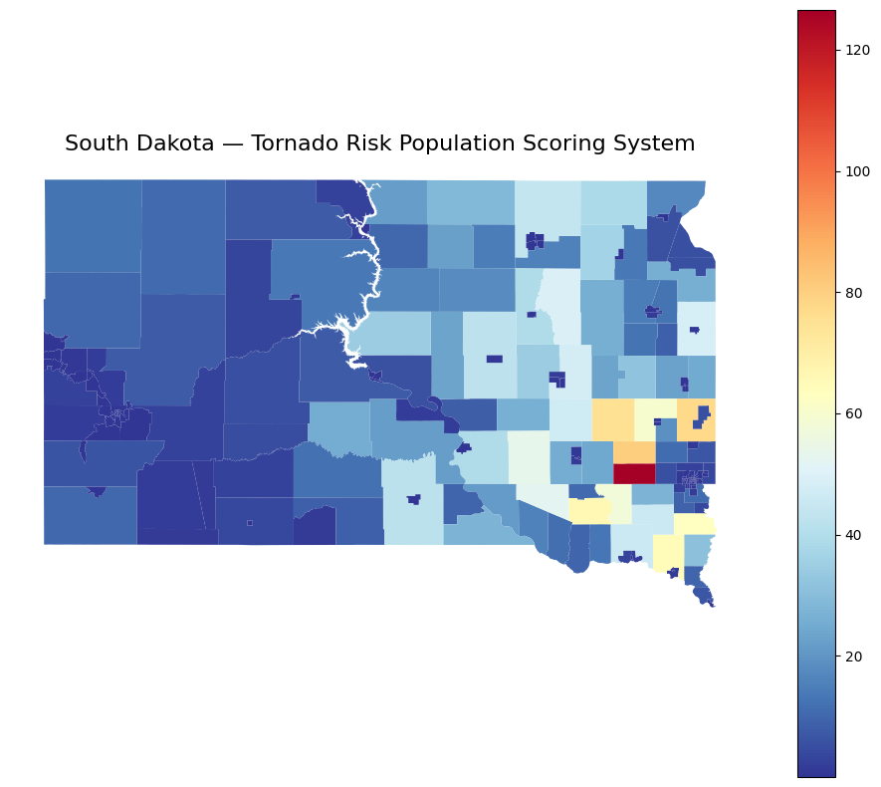
Figure 1displays the South Dakota map with the risk score we created

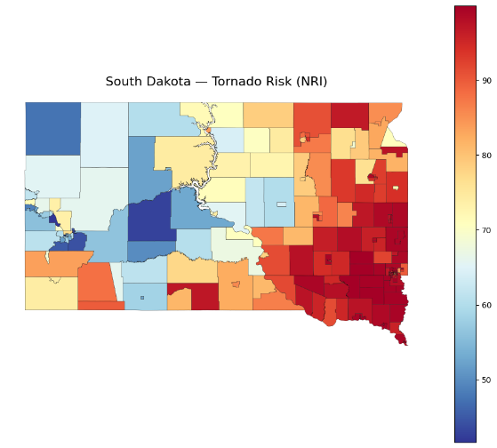
Figure 3 shows the tornado risk in South Dakota as defined by NRI

References
Federal Emergency Management Agency. (2026, April 8). Resilience analysis and planning tool (RAPT).

